KARE – PROJECT REPORT

Project Title: Investigating Brute Force Attacks using Authentication Logs
Student Name: M.V. Amuthan
Register Number / ID: 9923008046
Training Name: Cybersecurity Bug Bounties
College Name: Kalasalingam Academy of Research and Education

1. Abstract/Project Summary
This project focuses on identifying brute force attacks by analyzing authentication logs generated in a system. A brute force attack is a type of cyber attack where an attacker repeatedly tries different username and password combinations to gain unauthorized access. In this project, a Python-based log analysis tool was developed to parse authentication log data and detect suspicious login activities.
The system identifies repeated failed login attempts, suspicious IP addresses, and successful logins after multiple failures. It also provides a summary of targeted usernames and generates a simple investigation report. This project helps in understanding how authentication logs can be used for security monitoring and incident investigation in cyber security.

2. Introduction
Cyber security has become an important field due to the increasing number of attacks on computer systems and networks. One of the common attacks against login systems is the brute force attack. In this attack, an attacker continuously attempts different password combinations until access is gained.
Authentication logs are important sources of security information because they record successful and failed login attempts. By analyzing these logs, it is possible to identify suspicious behavior such as repeated login failures from the same IP address or login attempts on sensitive accounts such as root or admin.
The purpose of this project is to investigate brute force attack patterns using authentication logs. A Python script was developed to analyze sample log data and identify suspicious login behavior. This project demonstrates a simple but effective way to perform log-based attack detection.

3. Objectives
The main objectives of this project are:
- To understand the concept of brute force attacks
- To study the importance of authentication logs in cyber security
- To collect and analyze login-related log entries
- To identify repeated failed login attempts
- To detect suspicious IP addresses involved in possible brute force attacks
- To identify successful logins after multiple failures
- To generate a summary report for analysis and investigation

4. Tools and Technologies used

Software Used
- Python 3 – for writing the log analysis program
- Visual Studio Code (VS Code) – for editing and running the code
- GitHub – for uploading and maintaining the project repository
- Notepad – for creating the sample authentication log file
Files Used
- auth.log – sample authentication log file
- main.py – Python program for log analysis
- report.txt – output report generated by the program
Concepts Used
- Authentication log analysis
- Brute force attack detection
- Failed and successful login tracking
- IP-based attack identification

5. Methodology/Steps Performed
Step 1: Project Folder Creation
A project folder named BruteForceProject was created. Inside it, two folders were created:
- logs
- src
Step 2: Authentication Log File Preparation
A sample authentication log file named auth.log was created manually. The log file contains:
- Failed password attempts
- Accepted password logins
- Invalid user attempts
- Root and admin login attempts
- Multiple IP addresses
This log file simulates realistic brute force attack behavior.
Step 3: Python Program Development
A Python script named main.py was created inside the src folder. The program was designed to:
- Read the authentication log file
- Parse login events using regular expressions
- Identify failed and successful login attempts
- Count repeated failed logins by IP address
- Detect suspicious brute force patterns
- Display summary output
- Save results in a text report
Step 4: Running the Program
The Python script was executed using the following command:
python src/main.py
Step 5: Output Generation
The program displayed the analysis results in the terminal and also generated a file named report.txt containing the investigation summary.
Step 6: GitHub Repository Upload
The final project files were uploaded to GitHub for project hosting and submission.

Screenshot
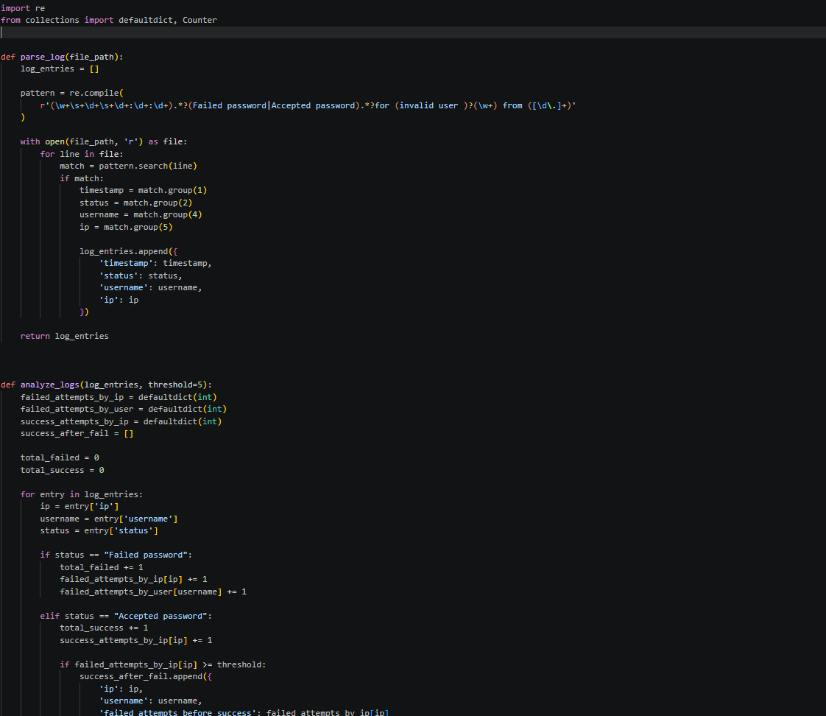

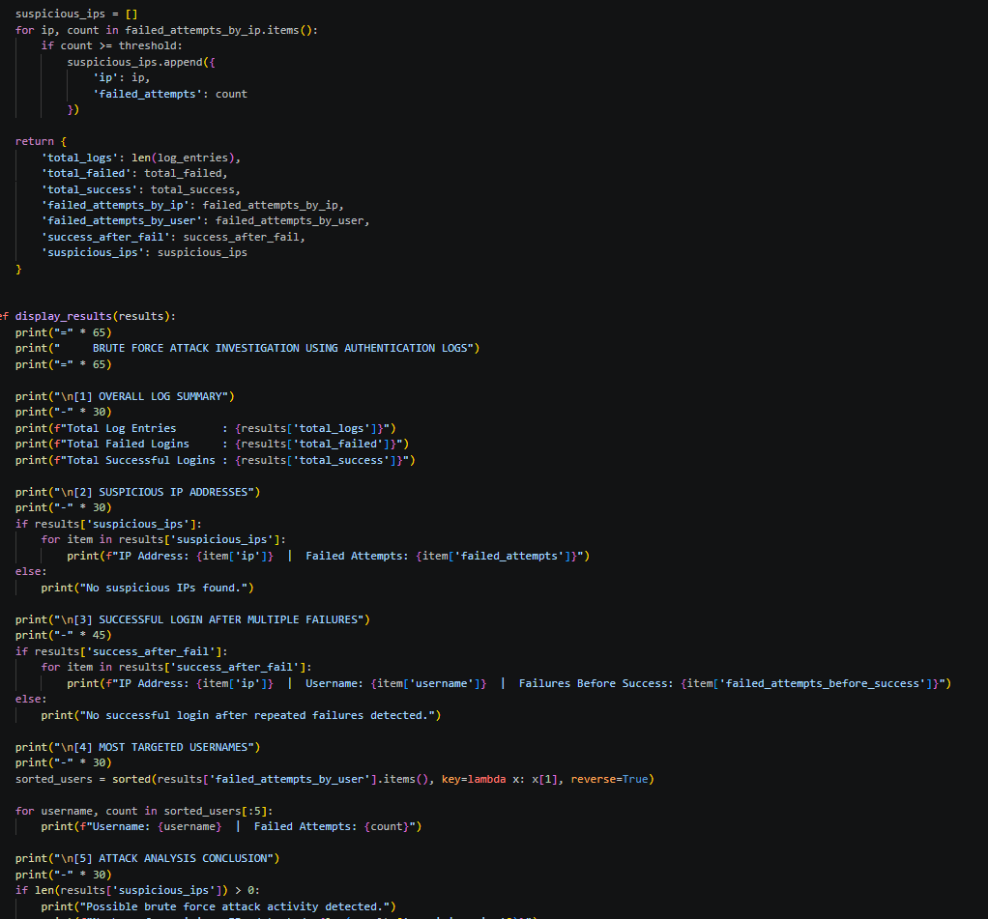

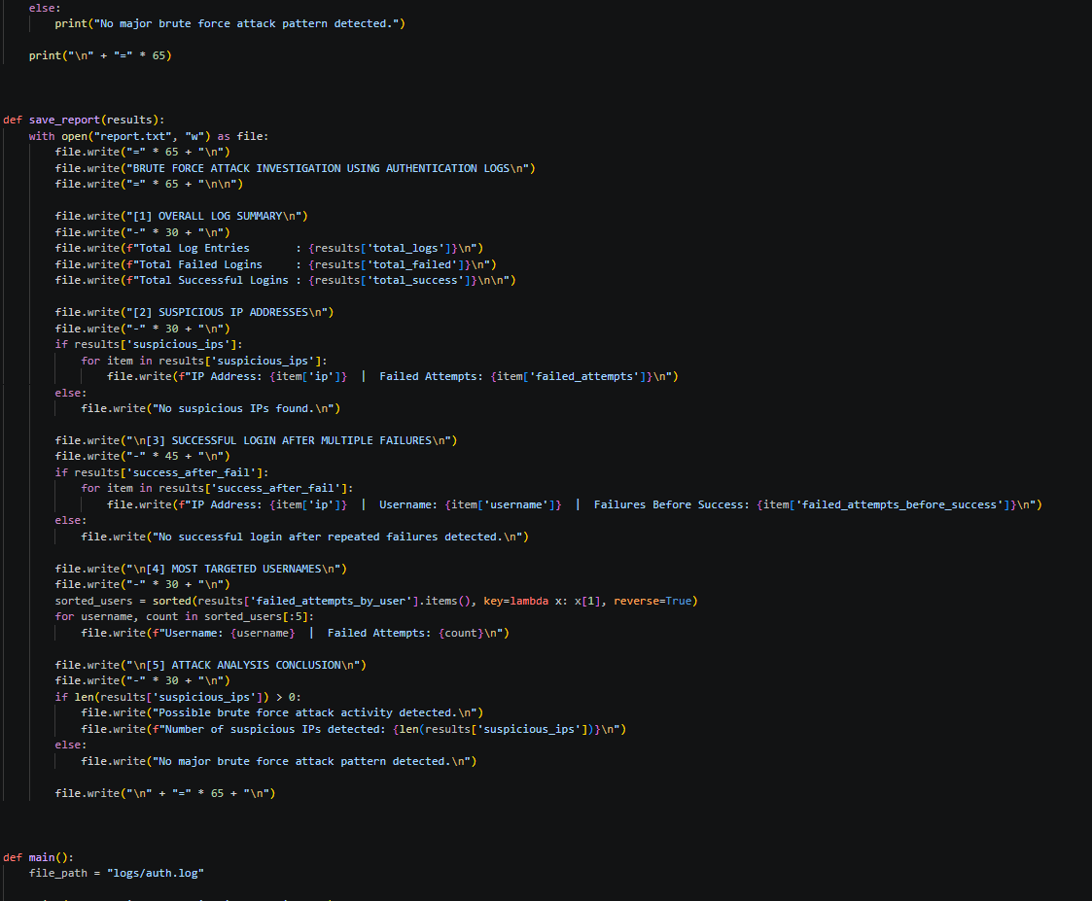

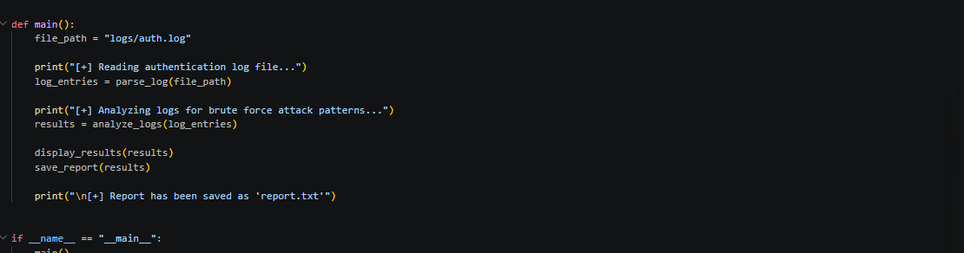

OUTPUT

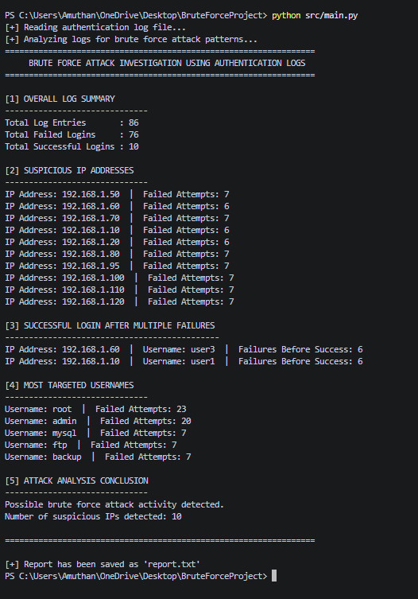

6. Program Code
import re
from collections import defaultdict, Counter

def parse_log(file_path):
log_entries = []

pattern = re.compile(
r'(\w+\s+\d+\s+\d+:\d+:\d+).*?(Failed password|Accepted password).*?for (invalid user )?(\w+) from ([\d\.]+)'
)

with open(file_path, 'r') as file:
for line in file:
match = pattern.search(line)
if match:
timestamp = match.group(1)
status = match.group(2)
username = match.group(4)
ip = match.group(5)

log_entries.append({
'timestamp': timestamp,
'status': status,
'username': username,
'ip': ip
})

return log_entries

def analyze_logs(log_entries, threshold=5):
failed_attempts_by_ip = defaultdict(int)
failed_attempts_by_user = defaultdict(int)
success_attempts_by_ip = defaultdict(int)
success_after_fail = []

total_failed = 0
total_success = 0

for entry in log_entries:
ip = entry['ip']
username = entry['username']
status = entry['status']

if status == "Failed password":
total_failed += 1
failed_attempts_by_ip[ip] += 1
failed_attempts_by_user[username] += 1

elif status == "Accepted password":
total_success += 1
success_attempts_by_ip[ip] += 1

if failed_attempts_by_ip[ip] >= threshold:
success_after_fail.append({
'ip': ip,
'username': username,
'failed_attempts_before_success': failed_attempts_by_ip[ip]
})

suspicious_ips = []
for ip, count in failed_attempts_by_ip.items():
if count >= threshold:
suspicious_ips.append({
'ip': ip,
'failed_attempts': count
})

return {
'total_logs': len(log_entries),
'total_failed': total_failed,
'total_success': total_success,
'failed_attempts_by_ip': failed_attempts_by_ip,
'failed_attempts_by_user': failed_attempts_by_user,
'success_after_fail': success_after_fail,
'suspicious_ips': suspicious_ips
}

def display_results(results):
print("=" * 65)
print(" BRUTE FORCE ATTACK INVESTIGATION USING AUTHENTICATION LOGS")
print("=" * 65)

print("\n[1] OVERALL LOG SUMMARY")
print("-" * 30)
print(f"Total Log Entries : {results['total_logs']}")
print(f"Total Failed Logins : {results['total_failed']}")
print(f"Total Successful Logins : {results['total_success']}")

print("\n[2] SUSPICIOUS IP ADDRESSES")
print("-" * 30)
if results['suspicious_ips']:
for item in results['suspicious_ips']:
print(f"IP Address: {item['ip']} | Failed Attempts: {item['failed_attempts']}")
else:
print("No suspicious IPs found.")

print("\n[3] SUCCESSFUL LOGIN AFTER MULTIPLE FAILURES")
print("-" * 45)
if results['success_after_fail']:
for item in results['success_after_fail']:
print(f"IP Address: {item['ip']} | Username: {item['username']} | Failures Before Success: {item['failed_attempts_before_success']}")
else:
print("No successful login after repeated failures detected.")

print("\n[4] MOST TARGETED USERNAMES")
print("-" * 30)
sorted_users = sorted(results['failed_attempts_by_user'].items(), key=lambda x: x[1], reverse=True)

for username, count in sorted_users[:5]:
print(f"Username: {username} | Failed Attempts: {count}")

print("\n[5] ATTACK ANALYSIS CONCLUSION")
print("-" * 30)
if len(results['suspicious_ips']) > 0:
print("Possible brute force attack activity detected.")
print(f"Number of suspicious IPs detected: {len(results['suspicious_ips'])}")
else:
print("No major brute force attack pattern detected.")

print("\n" + "=" * 65)

def save_report(results):
with open("report.txt", "w") as file:
file.write("=" * 65 + "\n")
file.write("BRUTE FORCE ATTACK INVESTIGATION USING AUTHENTICATION LOGS\n")
file.write("=" * 65 + "\n\n")

file.write("[1] OVERALL LOG SUMMARY\n")
file.write("-" * 30 + "\n")
file.write(f"Total Log Entries : {results['total_logs']}\n")
file.write(f"Total Failed Logins : {results['total_failed']}\n")
file.write(f"Total Successful Logins : {results['total_success']}\n\n")

file.write("[2] SUSPICIOUS IP ADDRESSES\n")
file.write("-" * 30 + "\n")
if results['suspicious_ips']:
for item in results['suspicious_ips']:
file.write(f"IP Address: {item['ip']} | Failed Attempts: {item['failed_attempts']}\n")
else:
file.write("No suspicious IPs found.\n")

file.write("\n[3] SUCCESSFUL LOGIN AFTER MULTIPLE FAILURES\n")
file.write("-" * 45 + "\n")
if results['success_after_fail']:
for item in results['success_after_fail']:
file.write(f"IP Address: {item['ip']} | Username: {item['username']} | Failures Before Success: {item['failed_attempts_before_success']}\n")
else:
file.write("No successful login after repeated failures detected.\n")

file.write("\n[4] MOST TARGETED USERNAMES\n")
file.write("-" * 30 + "\n")
sorted_users = sorted(results['failed_attempts_by_user'].items(), key=lambda x: x[1], reverse=True)
for username, count in sorted_users[:5]:
file.write(f"Username: {username} | Failed Attempts: {count}\n")

file.write("\n[5] ATTACK ANALYSIS CONCLUSION\n")
file.write("-" * 30 + "\n")
if len(results['suspicious_ips']) > 0:
file.write("Possible brute force attack activity detected.\n")
file.write(f"Number of suspicious IPs detected: {len(results['suspicious_ips'])}\n")
else:
file.write("No major brute force attack pattern detected.\n")

file.write("\n" + "=" * 65 + "\n")

def main():
file_path = "logs/auth.log"

print("[+] Reading authentication log file...")
log_entries = parse_log(file_path)

print("[+] Analyzing logs for brute force attack patterns...")
results = analyze_logs(log_entries)

display_results(results)
save_report(results)

print("\n[+] Report has been saved as 'report.txt'")

if __name__ == "__main__":
main()

7. Finding / Analyzing

The analysis of authentication logs revealed several suspicious patterns that are commonly associated with brute force attacks.
Important Findings
- Multiple IP addresses repeatedly attempted failed logins
- Sensitive usernames such as admin, root, mysql, ftp, and backup were heavily targeted
- Some IP addresses performed more than five failed login attempts, which is a strong indicator of brute force activity
- In certain cases, successful logins occurred after multiple failed attempts, which may indicate possible unauthorized access or suspicious login behavior
Attack Behavior Observed
The following brute force patterns were identified:
- Repeated failed login attempts from the same IP
- Multiple attacks against the same username
- Attempts against invalid users
- Suspicious successful login after repeated failures
This analysis shows that authentication logs can provide useful evidence for detecting and investigating cyber attacks.

8. Results

Main Results
- The program was able to read and parse the authentication log file successfully
- Failed and successful login attempts were identified correctly
- Suspicious IP addresses were detected based on repeated failed login attempts
- The program identified successful logins after multiple failures
- A report file was generated automatically
Example Output
The output of the program included:
- Total number of log entries
- Total failed logins
- Total successful logins
- Suspicious IP addresses
- Most targeted usernames
- Brute force investigation conclusion
Overall Result
The project achieved its objective of investigating brute force attacks using authentication logs and demonstrated how simple log analysis can be used in cyber security monitoring.

9. Challenges Faced

The following challenges were faced during the project:
- Understanding the structure of authentication logs
- Learning how to create and organize project files
- Using Python and VS Code as a beginner
- Writing code to correctly extract usernames, IP addresses, and login status
- Handling repeated failed attempts and suspicious login patterns
- Uploading the project to GitHub for the first time
These challenges were overcome by following step-by-step implementation and testing the project with sample log data.

10. Conclusion

This project, “Investigating Brute Force Attacks using Authentication Logs,” successfully demonstrates how authentication logs can be used to detect suspicious login activities and possible brute force attacks.
By analyzing repeated failed login attempts, targeted usernames, and successful logins after failures, the project helps in identifying abnormal authentication behavior. The project also highlights the importance of log analysis in cyber security and incident investigation.
Overall, this project provided practical exposure to authentication log monitoring, brute force detection, and basic cyber security investigation techniques.

11. Reference
- Python Official Documentation
- GitHub Official Documentation
- Visual Studio Code Official Documentation
- Linux Authentication Log Documentation

